**Branch :- Computer Science and Engineering Class :- III Year**

**Subject :- C-Skill Lab-IV Sem :- VI**

**Teacher Manual**

**PRACTICAL NO. 9**

**Aim:** Illustrate different stages of DevOps Pipeline (CI /CD).

**Theory:**

**DevOps pipeline** -

It is a set of automated processes and [tools](https://www.atlassian.com/devops/devops-tools) that allows both developers and operations professionals to work cohesively to build and deploy code to a production environment. While a DevOps pipeline can differ by organization, it typically includes build [automation/continuous integration](https://www.atlassian.com/continuous-delivery/continuous-integration), [automation testing](https://www.atlassian.com/continuous-delivery/software-testing), validation, and reporting. It may also include one or more manual gates that require human intervention before code is allowed to proceed.

Continuous is a differentiated characteristic of a DevOps pipeline. This includes continuous integration, [continuous delivery/deployment (CI/CD)](https://www.atlassian.com/continuous-delivery), continuous feedback, and continuous operations. Instead of one-off tests or scheduled deployments, each function occurs on an ongoing basis.

**Components of a DevOps pipeline –**

Continuous Integration/Continuous Delivery/Deployment (CI/CD)

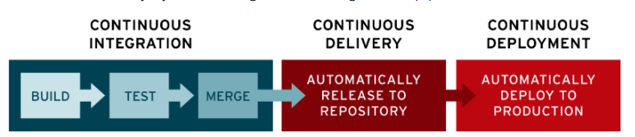

**Continuous integration-**

Continuous integration is a software development method where members of the team can integrate their work at least once a day. In this method, every integration is checked by an automated build to search the error. In continuous integration after a code commit, the software is built and tested immediately. In a large project with many developers, commits are made many times during a day. With each commit code is built and tested. If the test is passed, build is tested for Deployment. If the Deployment is a success, the code

is pushed to production. This commit, build, test, and deploy is a continuous process, and hence the name continuous integration/deployment.

**Continuous Delivery**

Continuous delivery is a software engineering method in which a team develops software products in a short cycle. It ensures that software can be easily released at any time. The main aim of continuous delivery is to build, test, and release software with good speed and frequency. It helps you to reduce the cost time and risk of delivering changes by allowing for frequent updates in production.

**Continuous Deployment**

  Continuous deployment is a software engineering process in which product functionalities are delivered using automatic deployment. It helps testers to validate whether the codebase changes are correct and stable or not. The team can achieve continuous deployment by relying on infrastructure that automates different testing steps. Once each integration meets these release criteria, the application is updated with a new code.

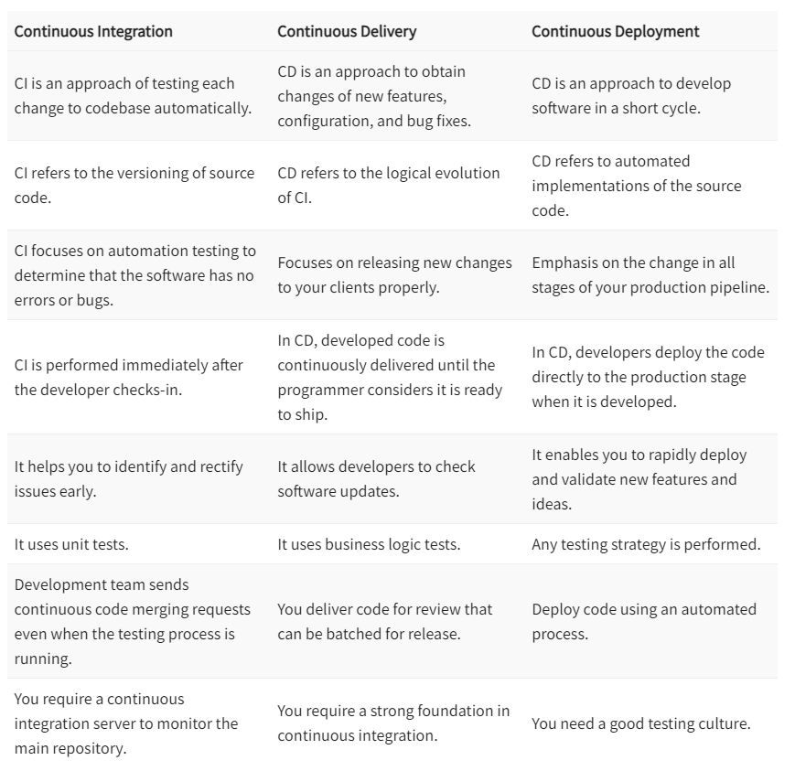

**Conclusion:** Thus, I have studied about different stages of DevOps Pipeline (CI /CD).